Tasks

Using MySQL Workbench, Navigate to Server -> Users and Privileges

1. Create a user **algonquin** with a password cst8250
   1. Allow the user to connect from any host on the network
   2. Grant the user **select**, **create view** and **show view** on the **world** database
   3. What is the equivalent sql command generated by MySQL to grant these to the users?  
        
      Command:  
      - CREATE USER 'algonquin'@'%' IDENTIFIED BY 'cst8250';  
      - GRANT SELECT, CREATE VIEW, SHOW VIEW ON world.* TO 'algonquin'@'%';
2. run the following command:
   1. **show grants for** [**algonquin@`192.168.0.%`**](mailto:algonquin@`192.168.0.%`)**;** (replace 192.168.0 with the ip address of your laptop).
   2. What is displayed? Hint: run show grants for algonquin@'%' to see the difference.  
        
      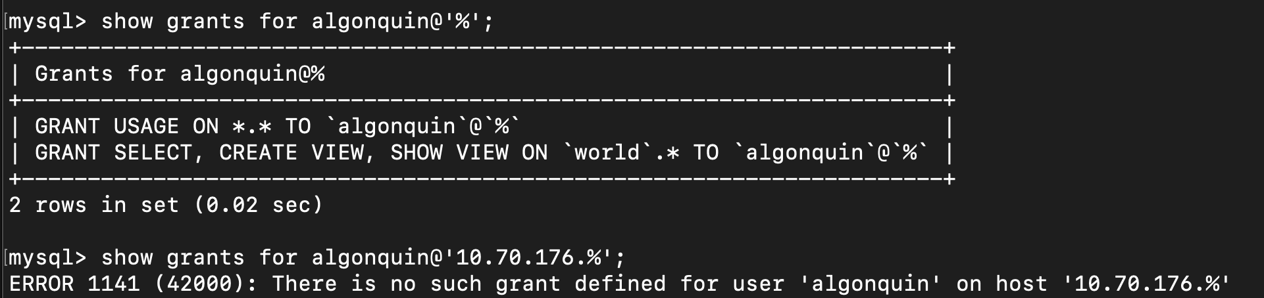
3. Open a second instance of MySQL using user **algonquin**, connect to the server.
4. Expand the tables and views of the schema and take a screenshot.  
   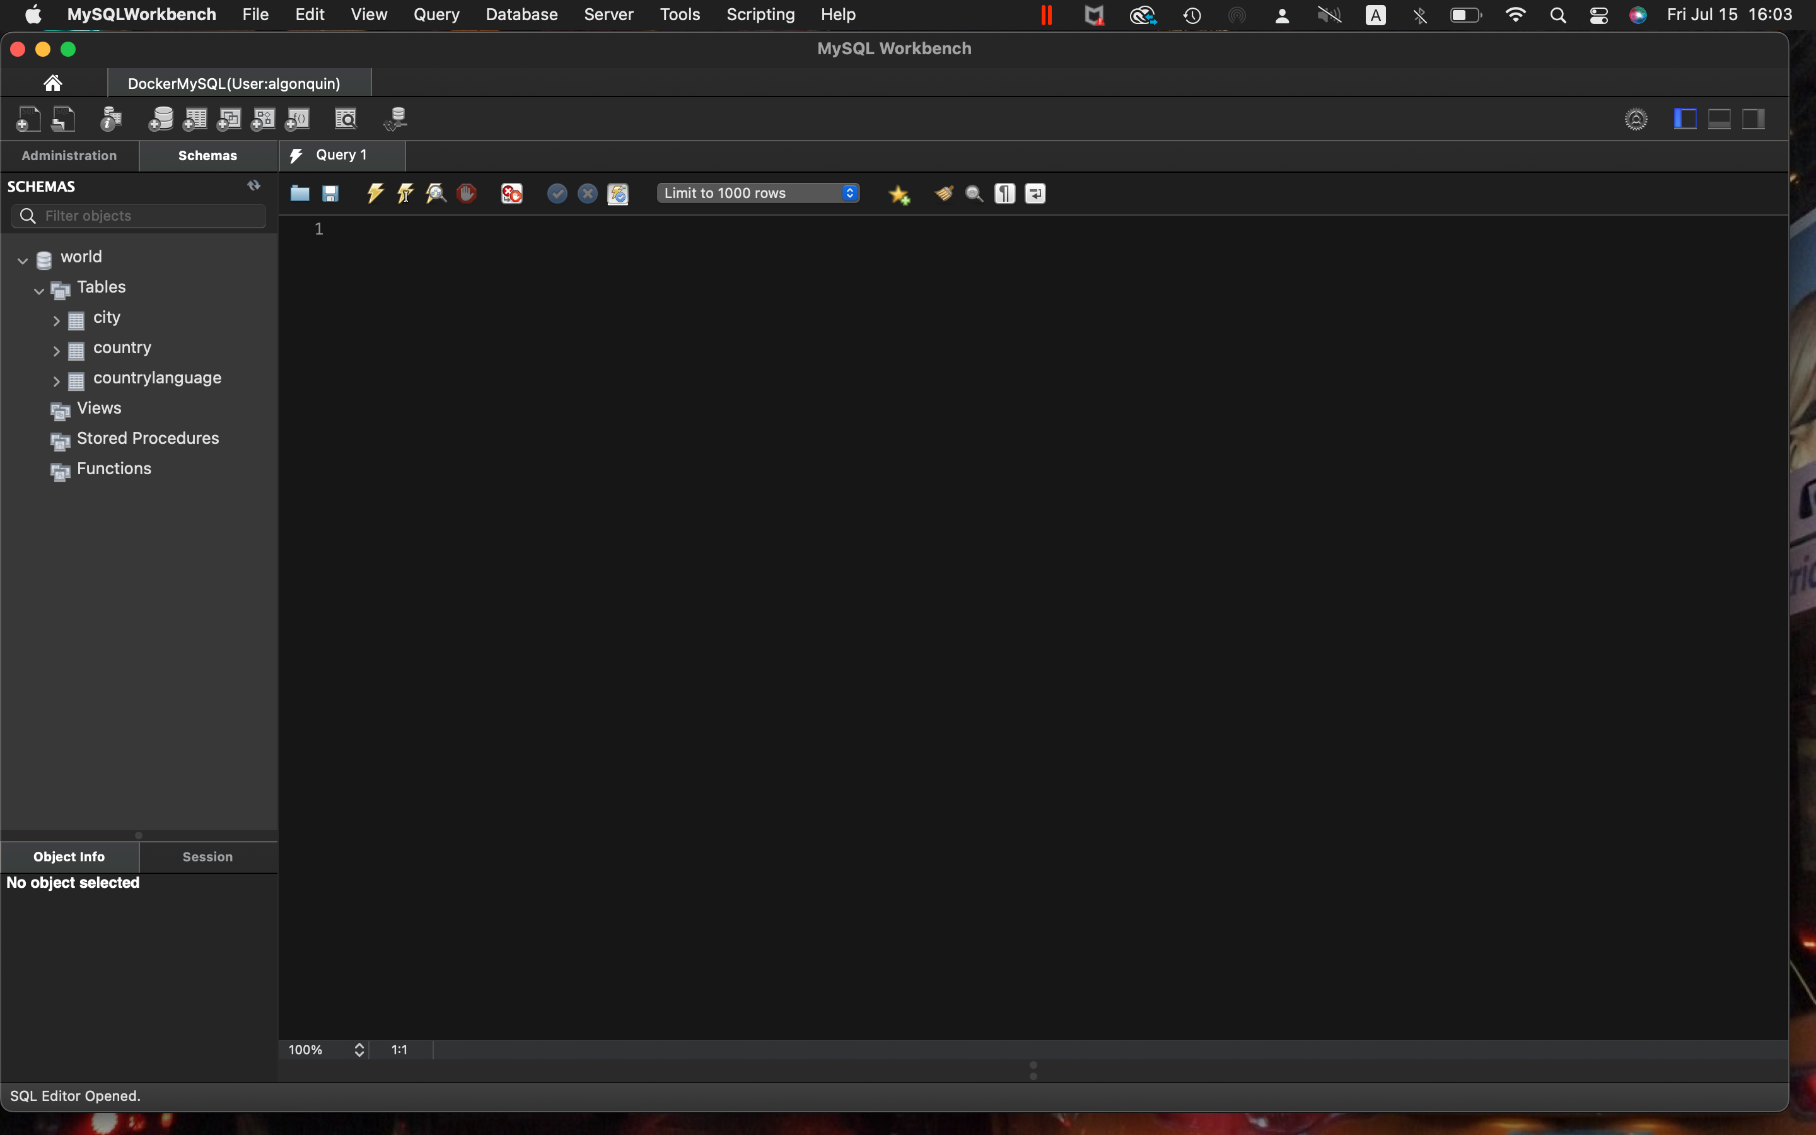
5. Can you access the User and Privileges Management link?  
     
   It says that ‘The account you are currently using does not have sufficient privileges to view the client connections.’  
   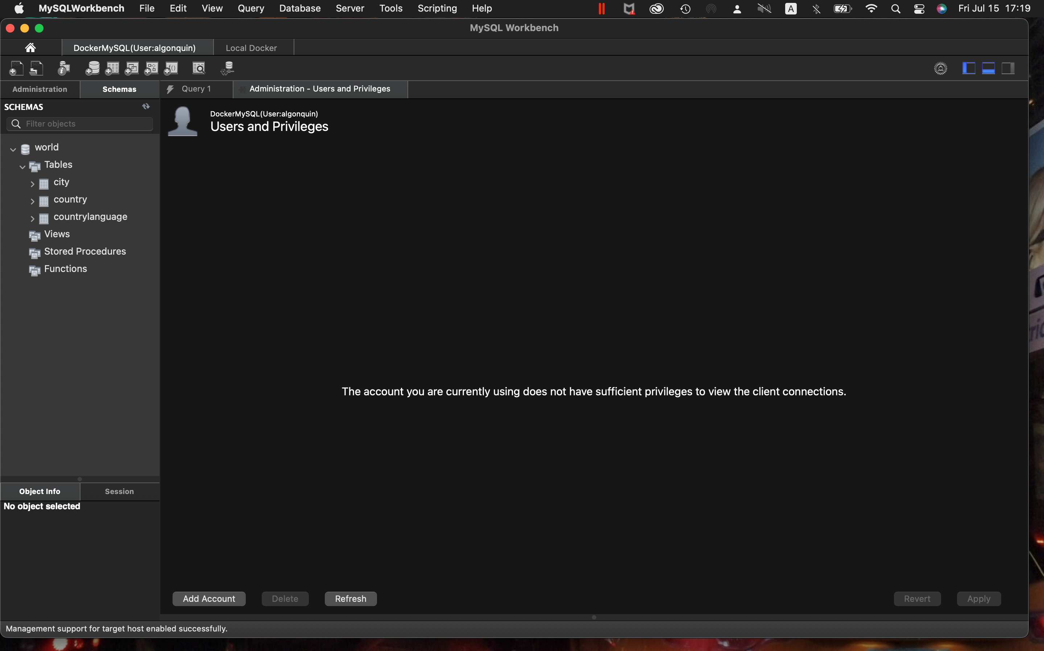
6. Why?  
   User algonquin doesn’t have right to see and change the User and Privileges.
7. Can you delete all the records in the city table?  
   No, I cannot.
8. What error code is provided by MySQL if any?  
     
   Error Code: 1142. DELETE command denied to user 'algonquin'@'172.17.0.1' for table 'city'
9. Close the MySQL instance.
10. Back to the main MySQL instance (user root)
11. Create a user associated with your first name and a password of your choice.
    1. Allow the user to connect from any host on the network
    2. **Click on the Administrative tab.**
       1. Spend some time to explore the built in administrative database role.
       2. What privileges are automatically associated to the built-in role **UserAdmin**?   
            
          CREATE USER, RELOAD
       3. What privileges are automatically associated to the built in role **DBManager**?  
          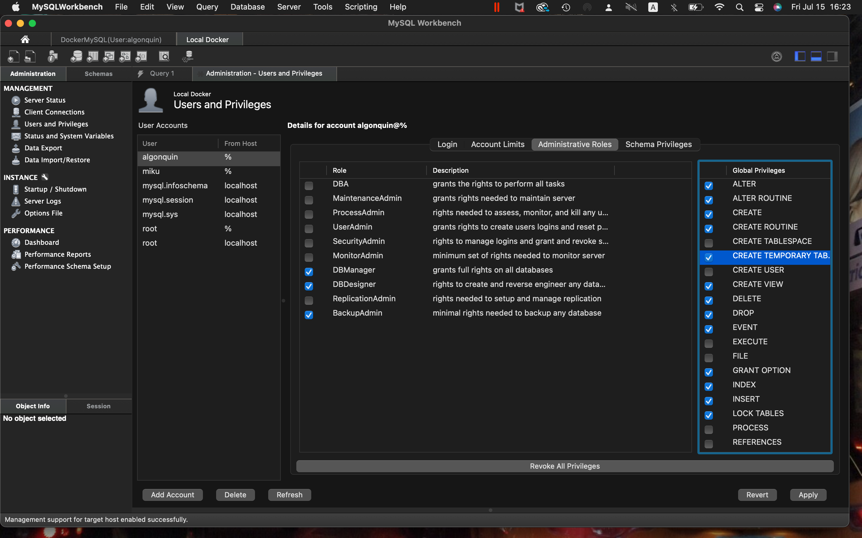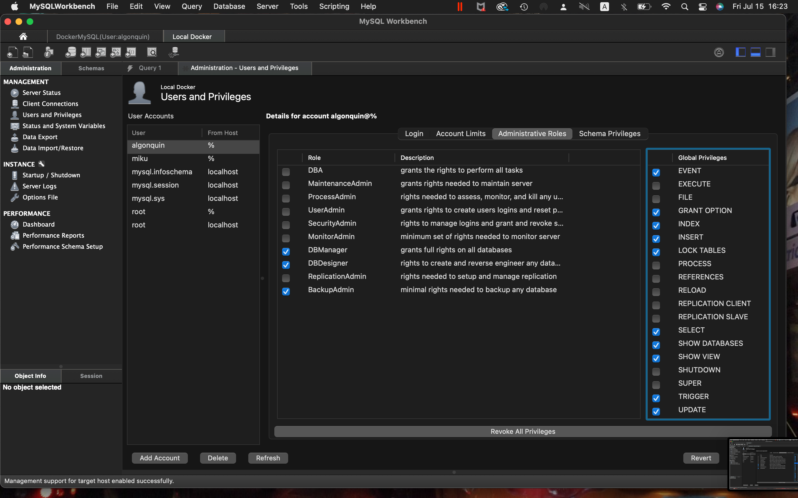  
          ALTER, ALTER ROUTINE, CREATE, CREATE ROUTINE, CREATE TEMPORARY TABLE
       4. Make the user created a member of the **DBDesigner** administative role.
       5. What privileges are automatically associated to it?   
          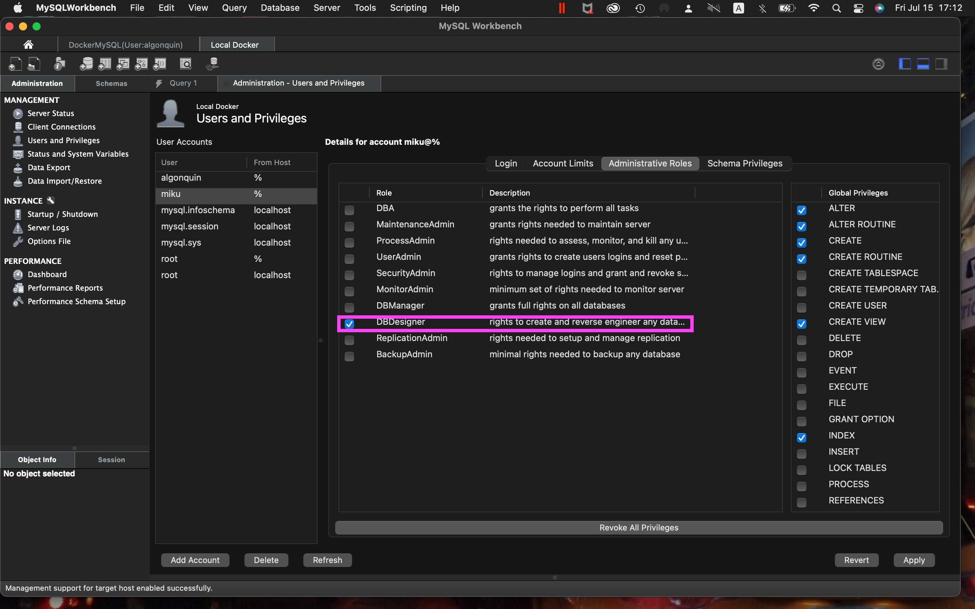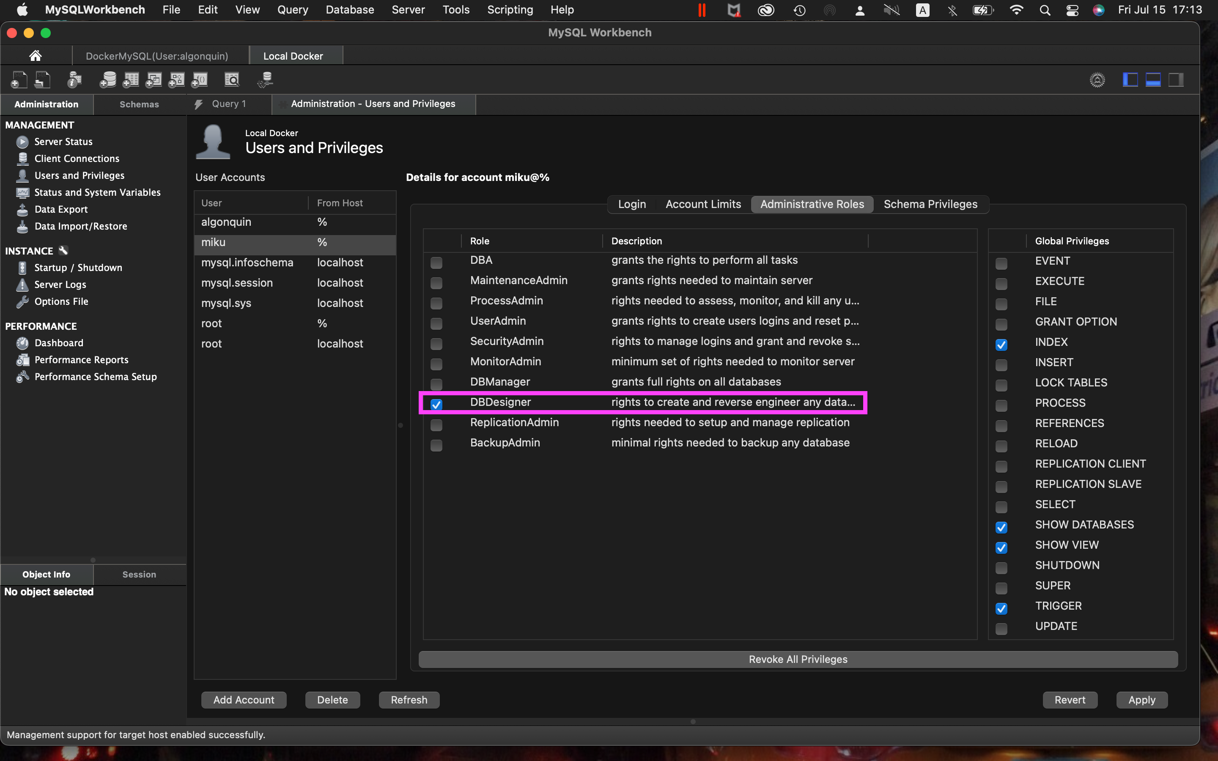
       6. Grant all Schema privileges to all schemas of your MySQL instance.  
          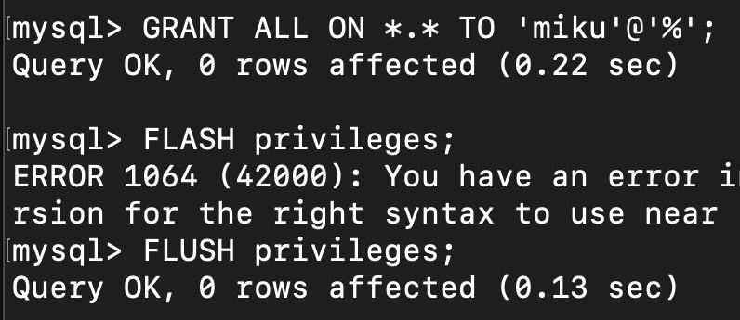
       7. Run the following command:
          1. **show grants for algonquin1@`%`;** (replace algonquin1 with the user name created in step 11)
          2. What is displayed?  
             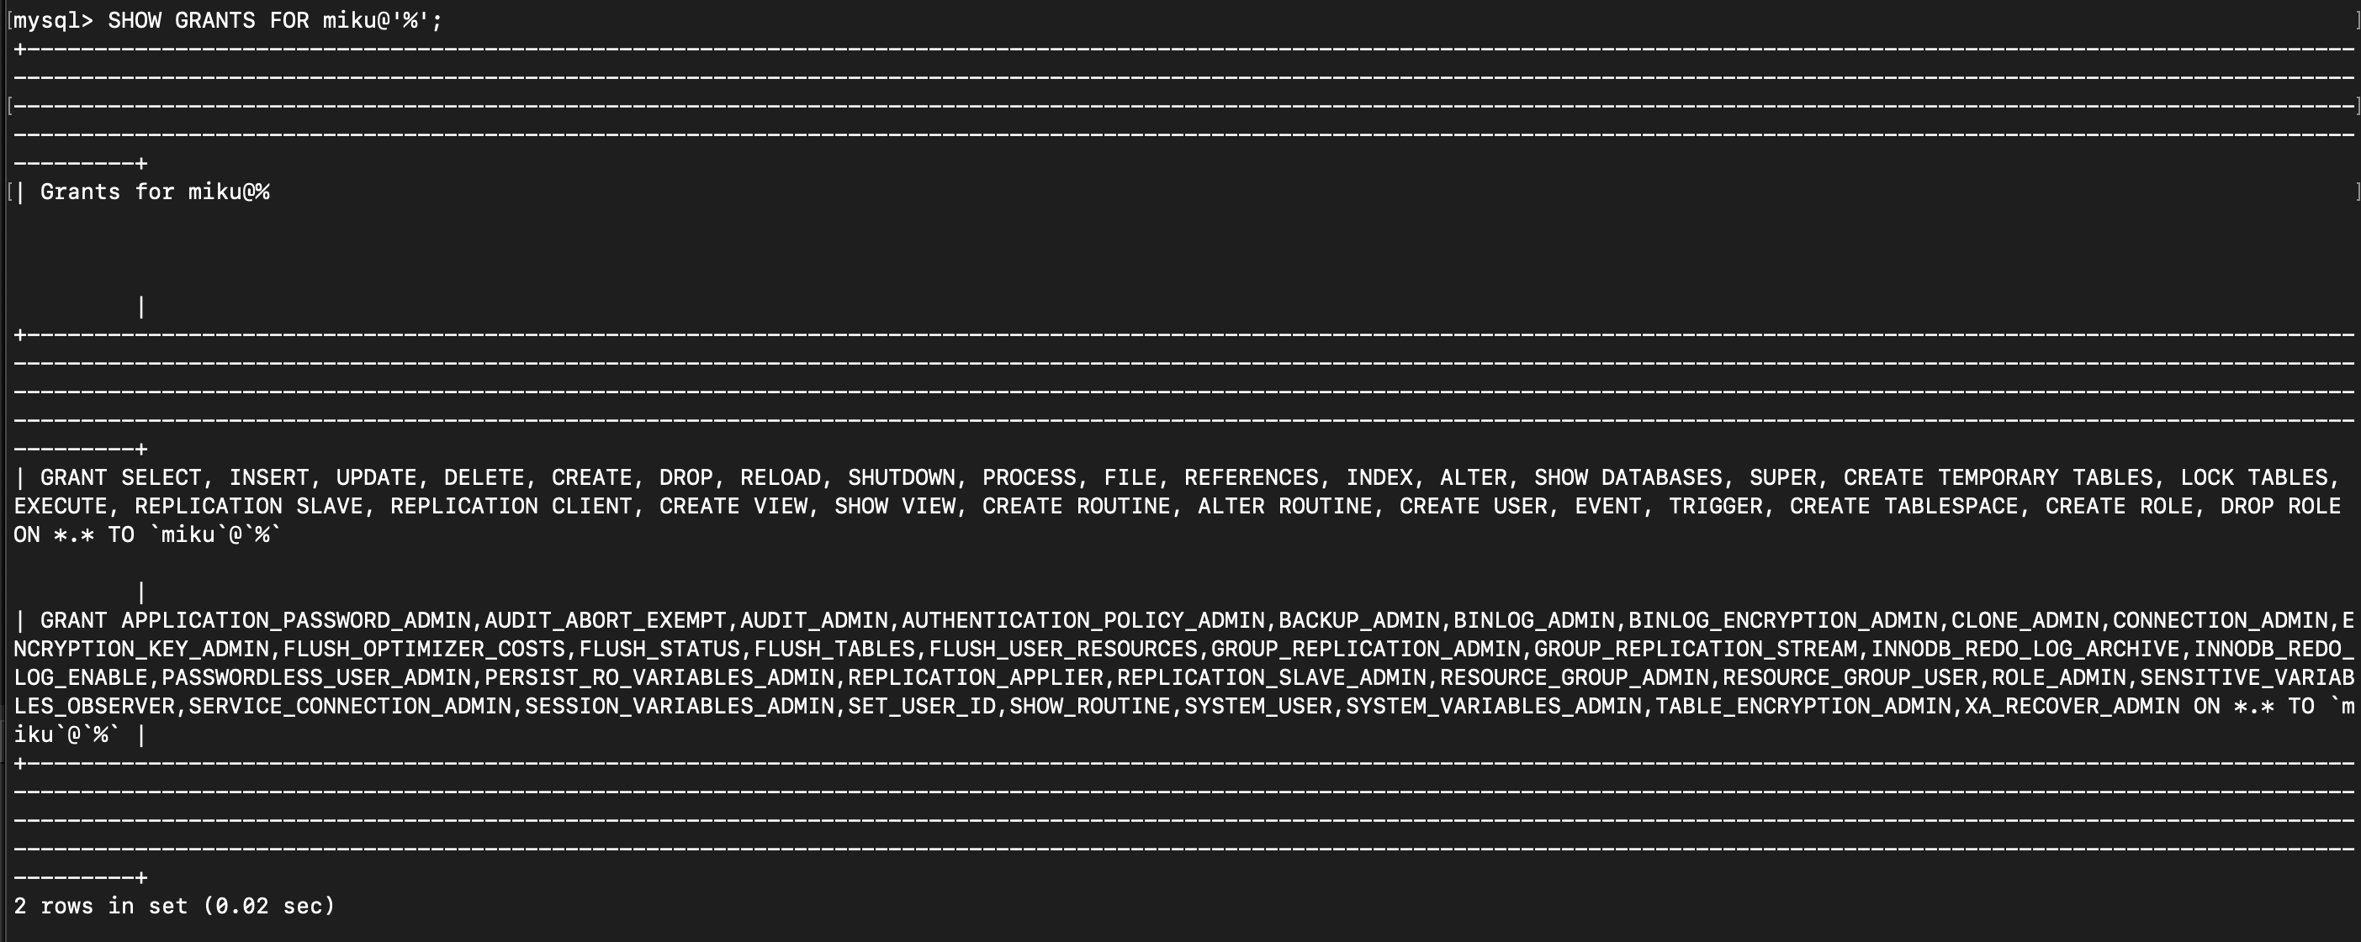
    3. Open a second instance of MySQL using the user created, connect to the server.
    4. Expand the tables and views of the schema and take a screenshot.  
       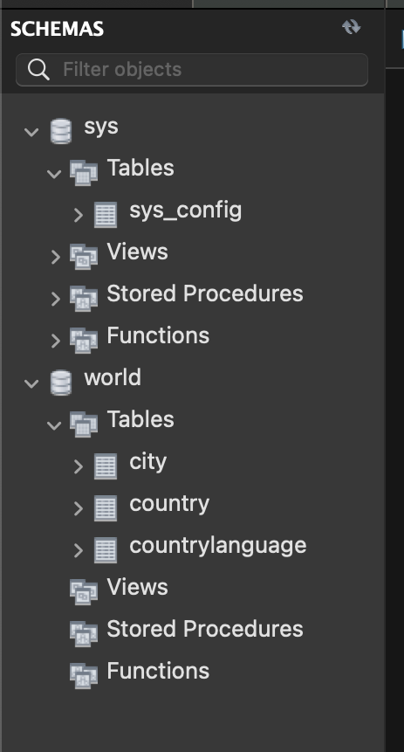
    5. Can you access the User and Privileges Management link?  
         
       Yes, I can.
    6. Why?  
         
       Because user Miku have all privileges.
    7. Can you create a new database?   
         
       Yes.  
       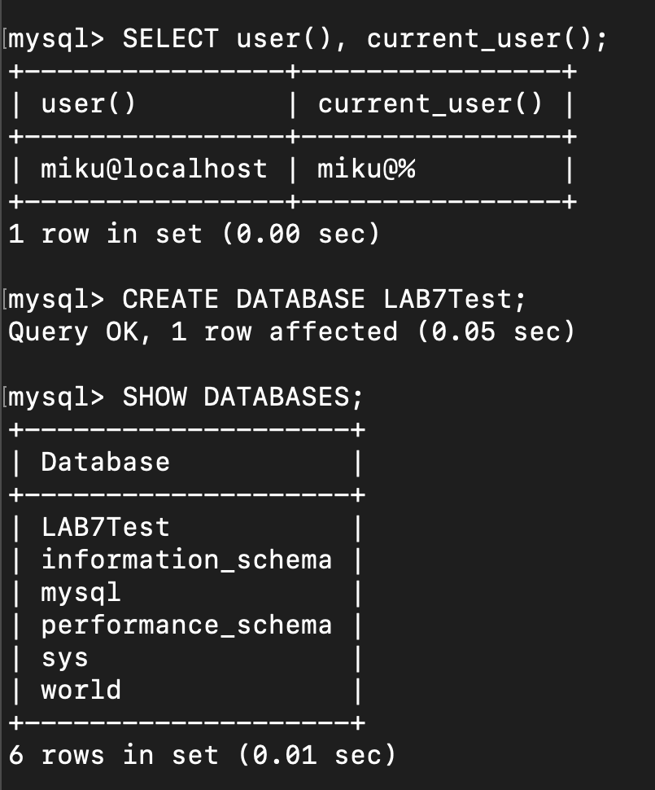
    8. What is the SQL command to remove all privileges to the 2 users you created?  
         
       